**Task-20 (Outputs)**

1. Date Picker.

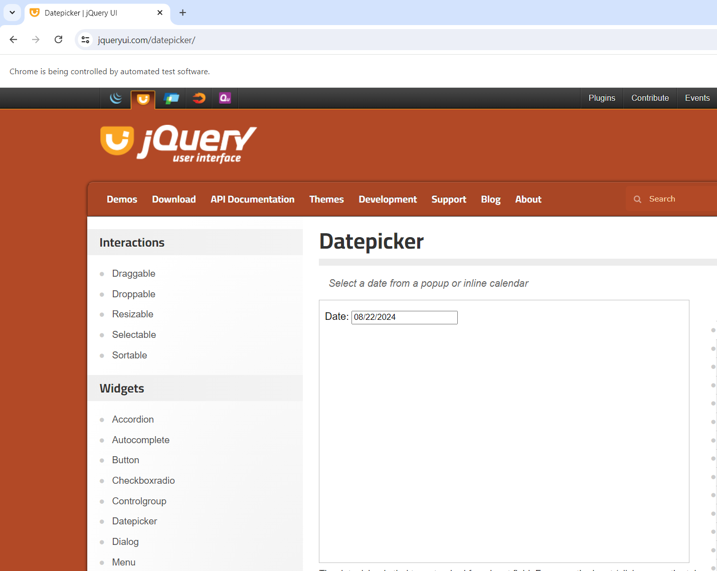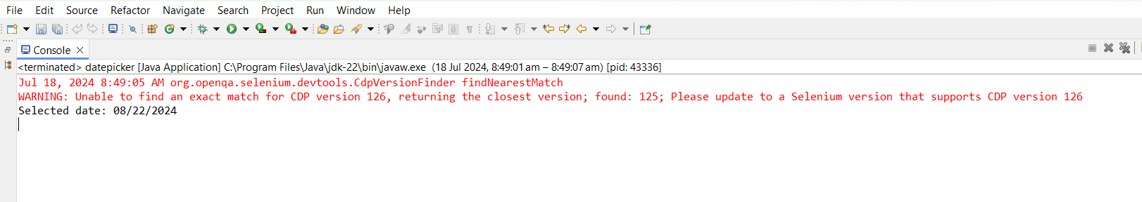

1. Sign up and login function.

